# Viewing Views - Solution

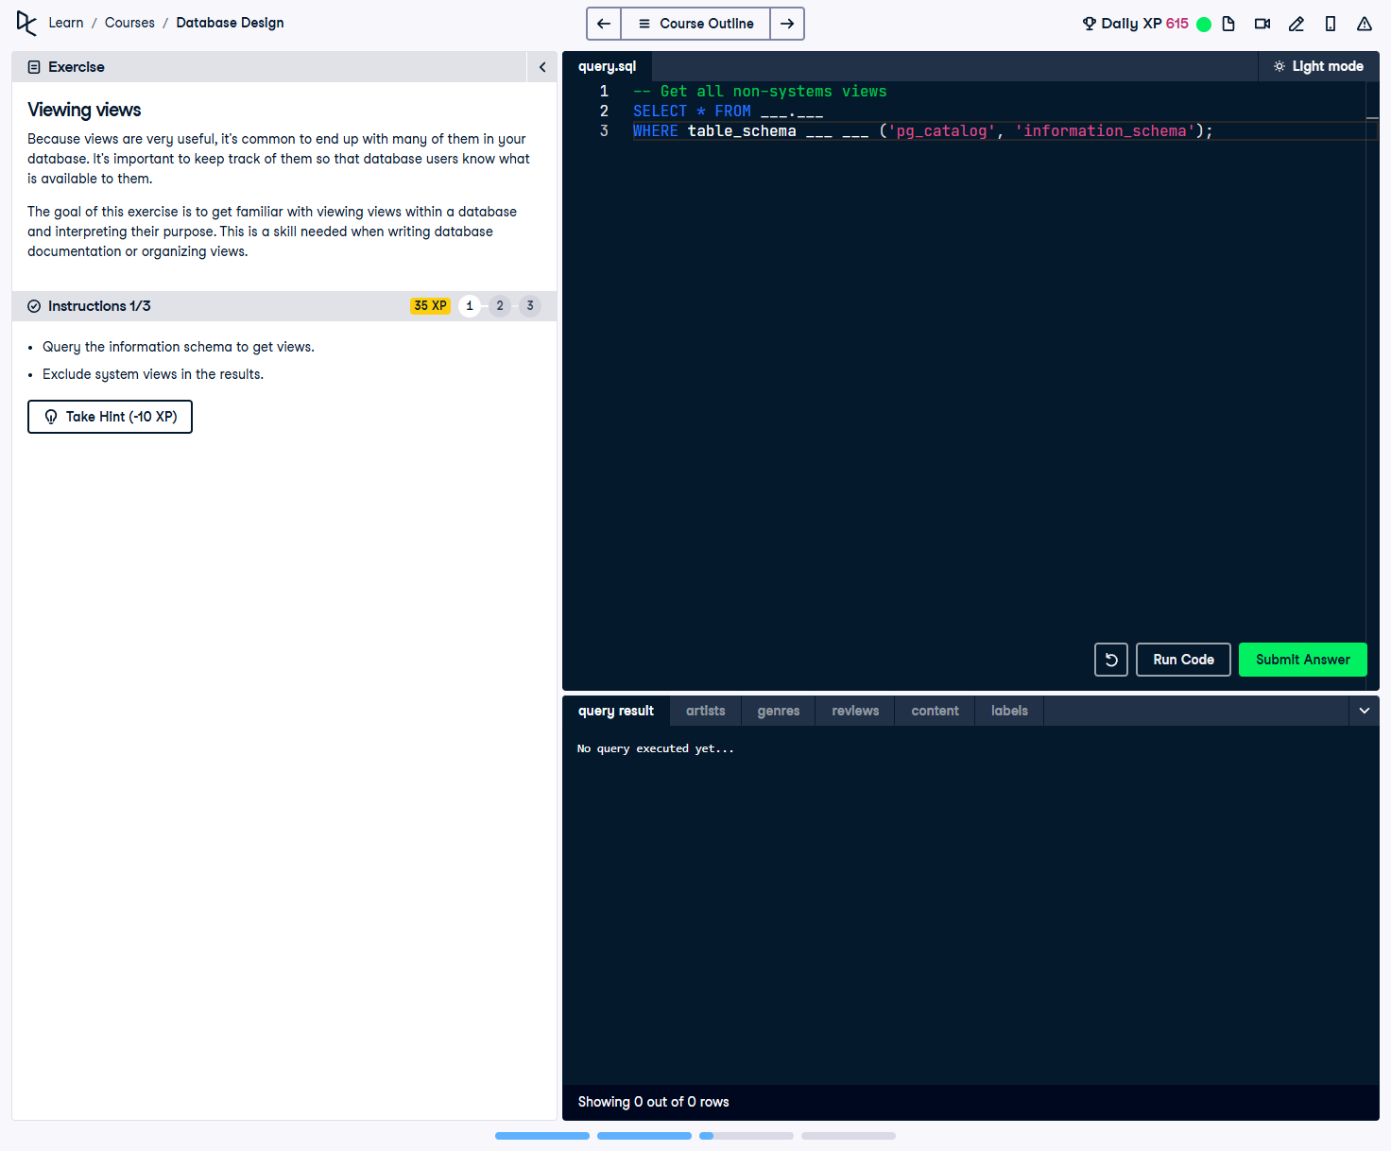

## Question

Because views are very useful, it’s common to end up with many of them in your database. It’s important to keep track of them so that database users know what is available to them.  
  
The goal of this exercise is to get familiar with viewing views within a database and interpreting their purpose. This is a skill needed when writing database documentation or organizing views.  
  
You need to:  
• Query the information schema to get views.  
• Exclude system views in the results.

## Final Corrected SQL Solution

-- Get all non-system views  
SELECT * FROM information_schema.views  
WHERE table_schema NOT IN ('pg_catalog', 'information_schema');

## Answer Explanation

1. **Querying `information_schema.views`:**  
 - The `information_schema.views` table contains metadata about all views in the database.  
  
2. **Filtering out system views:**  
 - System views are part of the PostgreSQL catalog (`pg_catalog`) and database schema (`information_schema`).  
 - The `WHERE table_schema NOT IN ('pg_catalog', 'information_schema')` condition ensures that only **user-defined views** are shown.  
  
3. **Usage:**  
 - Helps database administrators manage views effectively.  
 - Useful for documenting and organizing views for better database maintenance.